
Quick Start Guide:
Getting Started with Google Colab for
Machine Learning

  Document ID | TW-004
  Author | Swetha.V
  Date | 05-07-2026

1. OVERVIEW
Google Colab is a cloud-based platform that enables users to write, run, and share Python code through a web browser. It is widely used in artificial intelligence, machine learning, and data science because it requires no local installation and offers free access to computing resources.

2. INTENDED AUDIENCE
- Students
- AI and Machine Learning beginners
- Python learners
- Data science enthusiasts
- Anyone using Google Colab for the first time

3. REQUIREMENTS
- A Google account
- A stable internet connection
- A modern web browser
- Basic knowledge of Python (recommended)
4. QUICK START STEPS

Step 1 – Sign In
Open your preferred web browser and sign in with your Google account.

Step 2 – Open Google Colab
Go to the Google Colab website and wait for the homepage to load.

Step 3 – Create a New Notebook
Click New Notebook to create a blank notebook where you can write Python code.

Step 4 – Write Your First Program
Type a simple Python command, such as:
print("Hello, World!")

Step 5 – Run the Code
Click the Run button next to the code cell to execute the program.
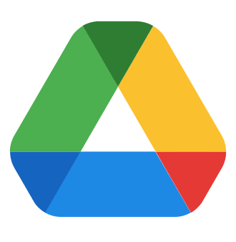
Step 6 – Save Your Notebook
Rename your notebook and confirm that it is automatically saved to Google Drive.


Quick Tip : Google Colab automatically saves your work to Google Drive, helping prevent data loss while you code.

5. VERIFY YOUR SETUP

Confirm that:

Google Colab opens successfully.

A new notebook is created without errors.

Python code runs successfully.
The notebook is automatically saved to Google Drive.

6. TIPS
- Give your notebooks meaningful names.
- Add comments to explain your code.
- Save important work regularly.
- Organize notebooks into folders.
- Use GPU acceleration only when your project requires it.

Issue | Solution
  Notebook does not load | Refresh the page and check your internet connection.
  Code does not execute | Restart the runtime and run the code again.
  Google account not detected | Sign out and sign back into your Google account.
  Notebook is not saving | Check your Google Drive storage and internet connection.
7. COMMON ISSUES
Note : If you continue to experience issues, refer to the official Google Colab documentation or the Google Help Center for additional support.

8. SUMMARY
Google Colab provides an easy-to-use environment for learning Python and developing AI or machine learning projects. By following the steps in this guide, users can quickly create notebooks, write code, execute programs, and begin exploring machine learning without installing software on their computer.


